

**Interação Pessoa-Máquina**

**2023/2024**

**The Modern Movie Database**

**_______________________________________________________**

Stage 5: Heuristic Evaluation



**Authors:** **Lab class Nº**  **3**

Guilherme Campos, 60353

João Santos, 61045 **Group Nº 17**

Miguel Valido, 60477

Pedro Fernandes, 60694 **Professora:**

Teresa Romão

Month 11, 2023

# Introduction

We received the functional prototype report from our colleagues on November 21st. We took our time to test the prototype and delivered the report involving the problems found on November 22nd.

# Identified problems

These are the heuristic violations we uncovered:

|  |  |  |  |  |  |  |
| --- | --- | --- | --- | --- | --- | --- |
| Nº | Problem | Heuristic | Description | Severity | Solution | Screenshot |
| 1 | Language Inconsistency | Consistency & Standards | Most of the website was written in English, but some text is written in Portuguese | 1/Cosmetic  Rare, easy and rare to overcome | Translate the Portuguese terms to English. | Figure 1 |
| 2 | Naming Inconsistency | Consistency & Standards | Comparation List and Comparator List are the same thing but share different names | 1/Cosmetic  Rare, easy and rare to overcome | Choose one term on every usage, such as “Comparison List” | Figure 2 |
| 3 | Sort by Photo | Error Prevention | It is possible to sort the list of cars by photo, despite this not being a legal operation | 1/Cosmetic  Rare, easy and rare to overcome | Disable sorting by Image | Figure 3 |
| 4 | Advanced search by Brands | Flexibility & Efficiency of Use | If the user doesn’t want to filter by brand, it isn’t efficient to select every brand one by one | 3/Major  Common, difficult and infrequent to overcome | When empty, it should show every brand | Figure 4 |
| 5 | Unnecessary advanced search confirmation | Flexibility & Efficiency of Use | Not efficient to be constantly confirming an operation that is not important. Confirmation boxes should only be used in stateful operations. | 2/Minor  Common, easy and frequent to overcome | Remove said confirmation | Figure 5 |
| 6 | Listing is not obvious | Aesthetic & Minimalist Design | There is only an icon to click, and it is not obvious what it does just by looking. | 1/Cosmetic  Frequent, easy and rare to overcome | Include a label to indicate what the icon means | Figure 6 |

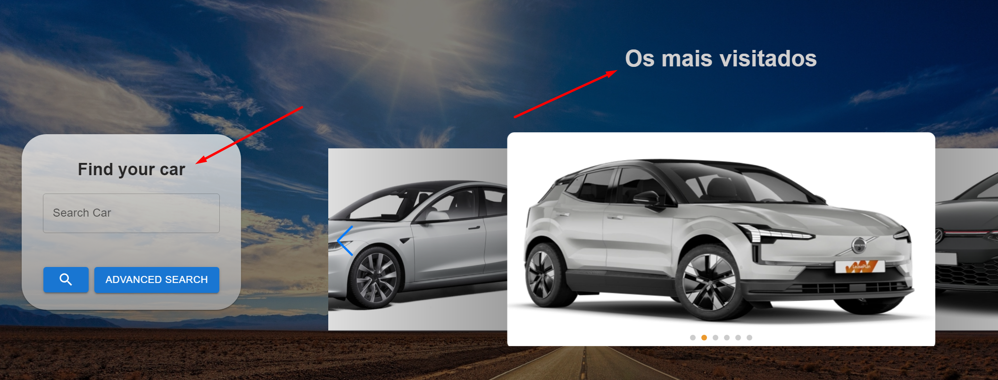

Figure 1: Inconsistent language

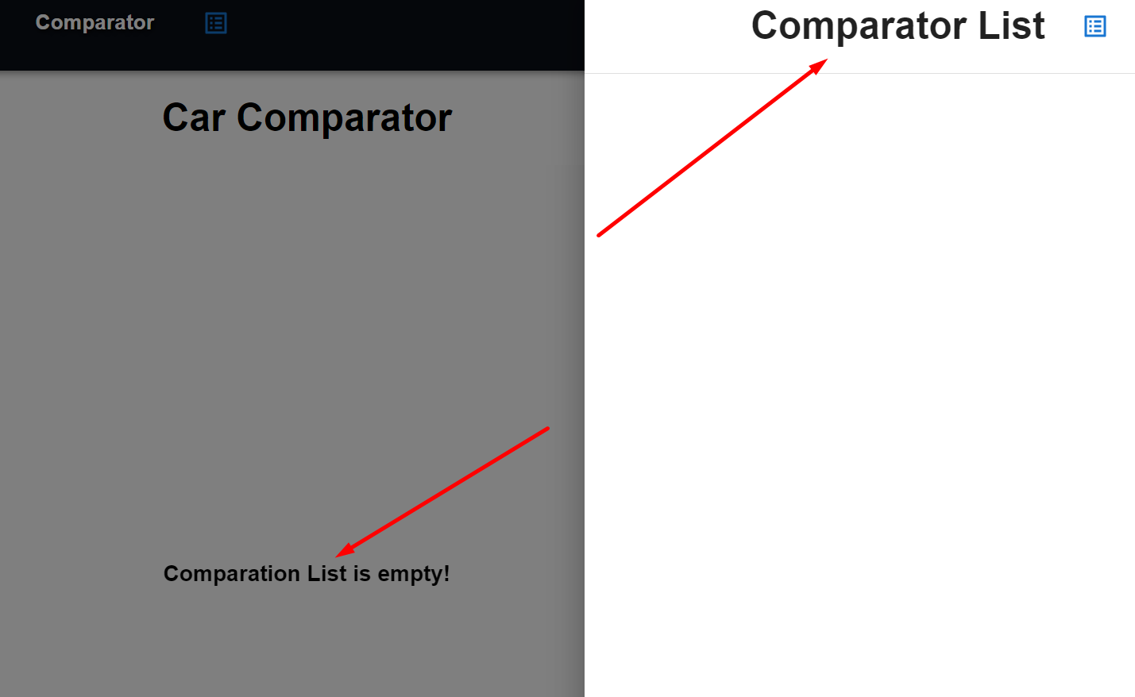

Figure 2: Inconsistent naming

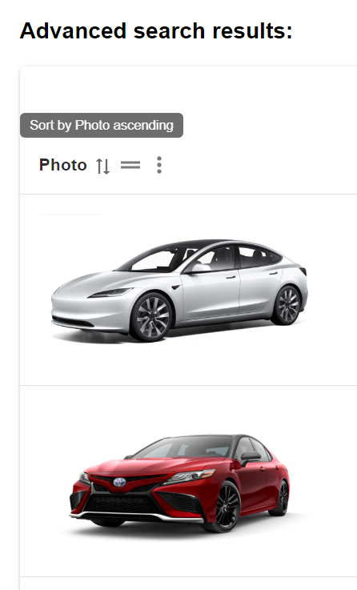

Figure 3: Sorting by photo

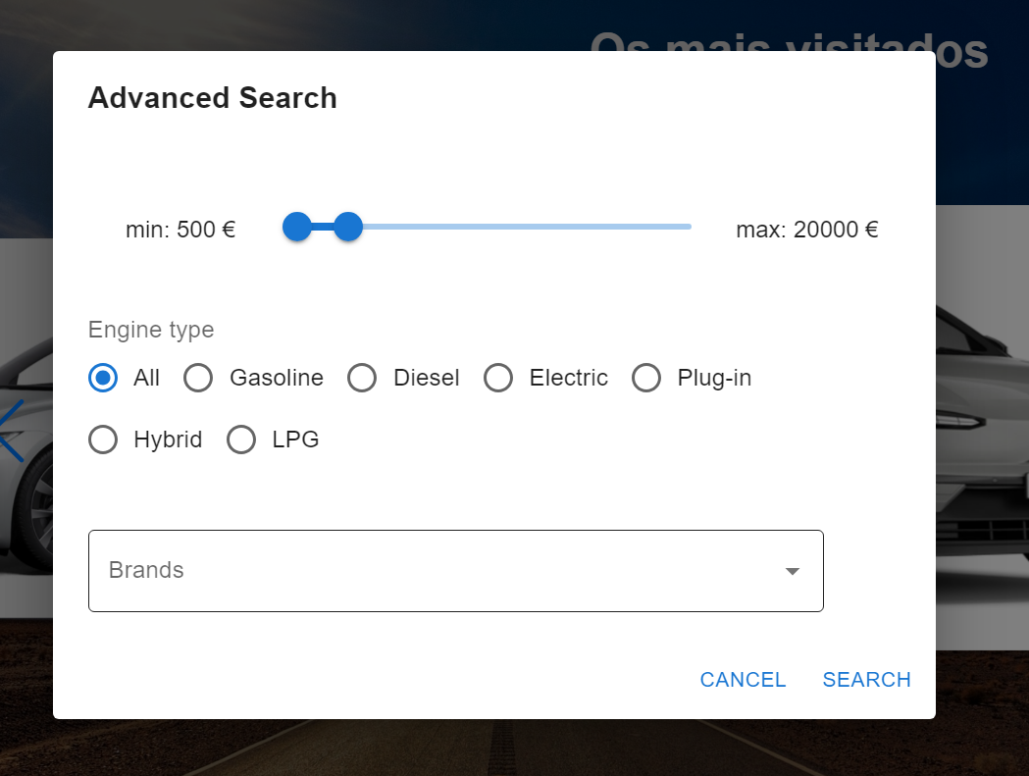

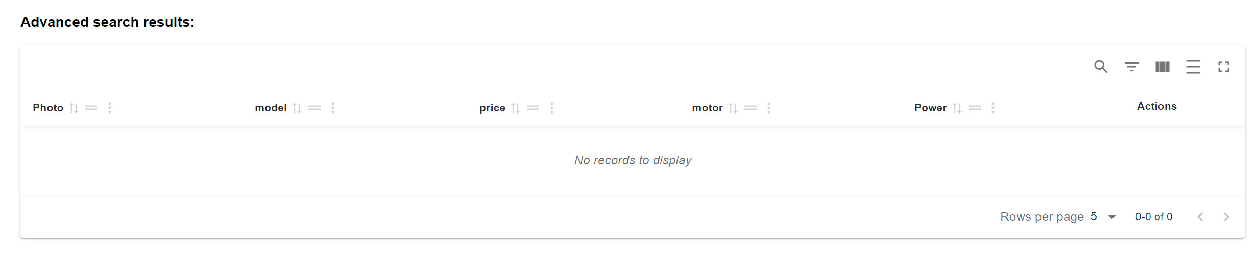

Figure 4: Advanced search by Brands

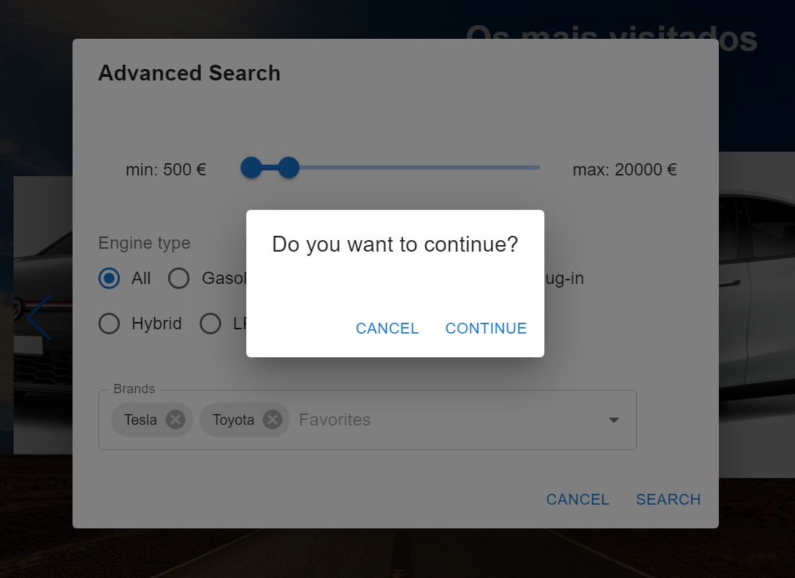

Figure 5: Search confirmation

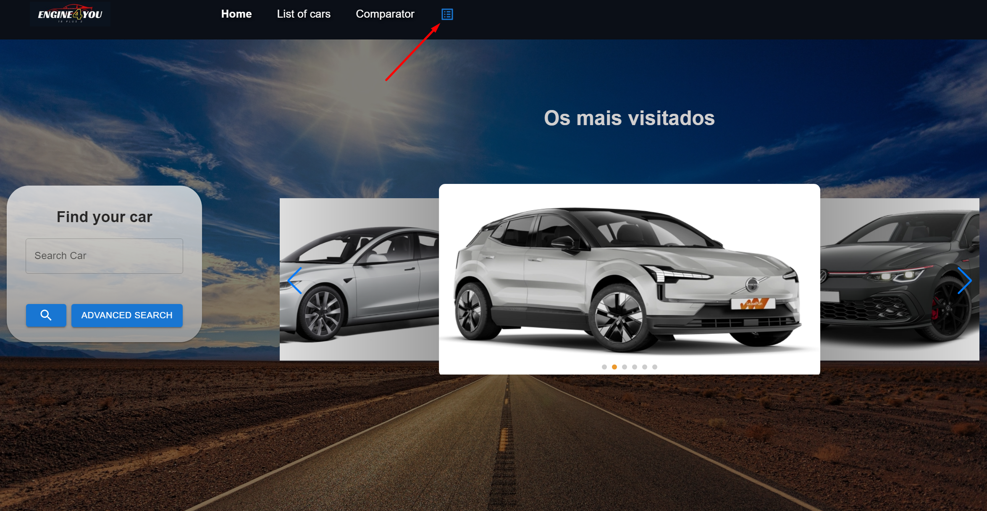

Figure 6: Listing icon

# Functionality Errors

When using advanced search, you will get to the page “/list/advanced”. On this page, sorting the results by engine power does not work properly.

Also, when using advanced search, and adding filters, there is no way of filtering by the number of seats. This is particularly important for the last scenario (Rodrigo wants a car with 5 seats).

# Summary

Overall, we found the application developed by our colleagues quite useful. There were no catastrophic issues found, however quite a few minor and cosmetic problems were. We hope they will be addressed, and that the website will become even better.